Front-End UI/UX Mini Project

Project Submission Template

**1. Title Page**

* Project Title: “Curate Studio – Interior Design Portfolio Website”
* Submitted By:
  + Team Members : SAHASRA T

JOEL THOMAS MARIO J

CHRIS DERICK QUADROS

o Roll Number: 2463048

2463029

2463015

* + College-E-mail Id : sahasra.t@btech.christuniversity.in

joel.thomasmario@btech.christuniversity.in

chris.derick@btech.christuniversity.in

* Course: UI/UX Design Fundamentals
* Instructor Name: Dhiraj
* Institution: Christ University
* Date of Submission: 13/08/2025

# **2. Abstract**

This project is a responsive website for Curate Studio, an interior design company. Built using HTML and CSS, the site highlights the company’s philosophy, services, portfolio, testimonials, and contact details into its own html pages , making it a multipage website. The goal was to create a visually appealing and functional platform that reflects the studio’s aesthetic vision while offering a user-friendly browsing experience. Core technologies include HTML5 and pure CSS. The final output is a clean, modern, and fully responsive design that effectively showcases Curate Studio’s work and brand identity.

# **3. Objective**

* Design a professional, minimal, and modern interface.
* Present services and portfolio in an organized, filterable format.
* Implement a CSS-only portfolio filter.
* Showcase client testimonials in an animated carousel.
* Ensure full responsiveness across devices.

# **4. Scope of the Project**

* Pure front-end development with HTML & CSS.
* Includes CSS-based interactivity without JavaScript.
* Responsive layout for desktop, tablet, and mobile.
* Covers brand introduction, services, portfolio, testimonials, & contact.

# 5. Tools & Technologies Used

|  |  |
| --- | --- |
| Tool/Technology | Purpose |
| HTML5 | Markup and content structure |
| CSS3 | Styling and layout management |
| VS Code | Code editor |
| Chrome DevTools | Testing and debugging |

# **6.** **HTML Structure Overview**

* Sections: Header, Hero, About, Services, Portfolio, Testimonials, Footer.
* Semantic tags: <header>, <section>, <footer>.
* Portfolio filter using hidden checkboxes and labels.

# **7. CSS Styling Strategy**

* CSS variables for color theming.
* Flexbox & Grid for layout arrangements.
* CSS animations for testimonial carousel.
* Media queries for mobile responsiveness.
* Box shadows and border accents for depth.

# **8. Key Features**

|  |  |
| --- | --- |
| Feature | Description |
| Responsive Layout | Works across all device sizes. |
| Hero banner | Large, immersive background image |
| Services section | Clear list of offerings |
| Filterable Portfolio | CSS-only category filtering |
| Testimonials Carousel | Automatic sliding quotes |
| Contact Details | Email and phone displayed in footer |

# **9. Challenges Faced & Solutions**

|  |  |
| --- | --- |
| Challenge | Solution |
| Complex portfolio filtering without JS | Used hidden checkboxes with CSS sibling selectors. |
| Testimonials animation timing | Fine-tuned keyframe percentages. |
| Maintaining image proportions | Used object-fit: cover for consistency |

# **10. Outcome**

* The project successfully delivers a stylish, functional, and responsive interior design website. Visitors can explore services, filter through portfolio items, read testimonials, and find contact details effortlessly.

# **11. Future Enhancements**

* Add JavaScript for smoother filter animations and dynamic loading.
* Backend form for client inquiries.
* Light/Dark mode toggle.

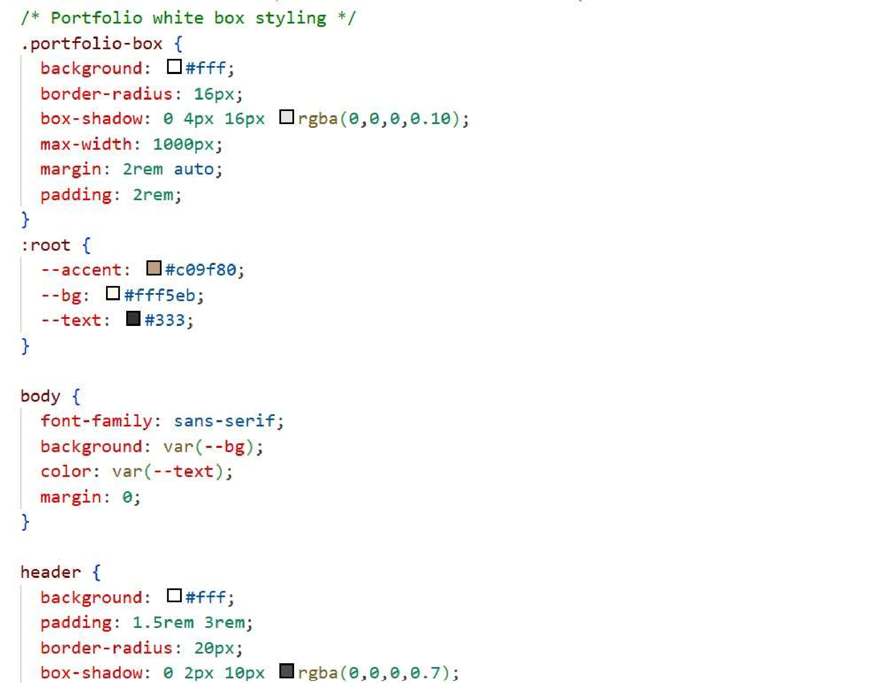12. Sample Code

CSS code for portfolio page :

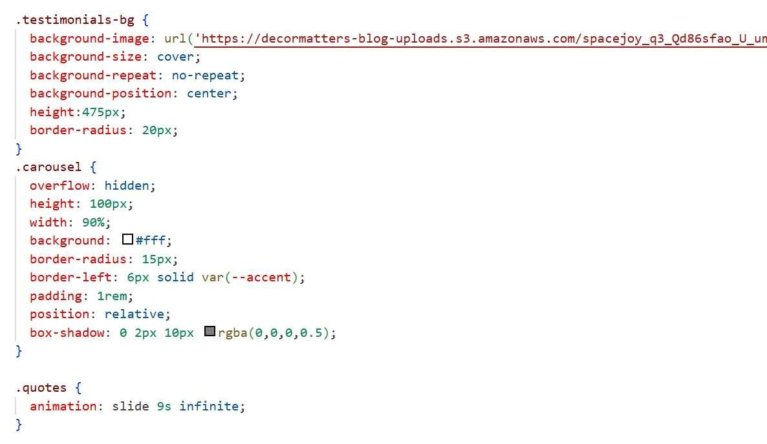

HTML code for testimonials:

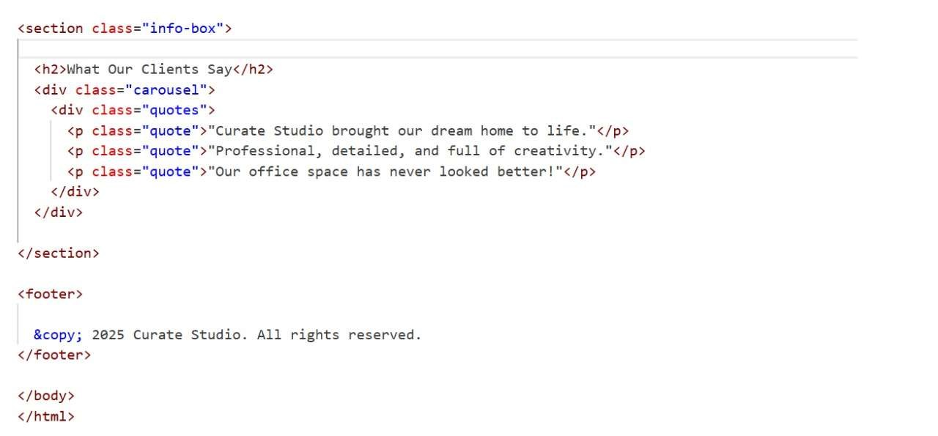

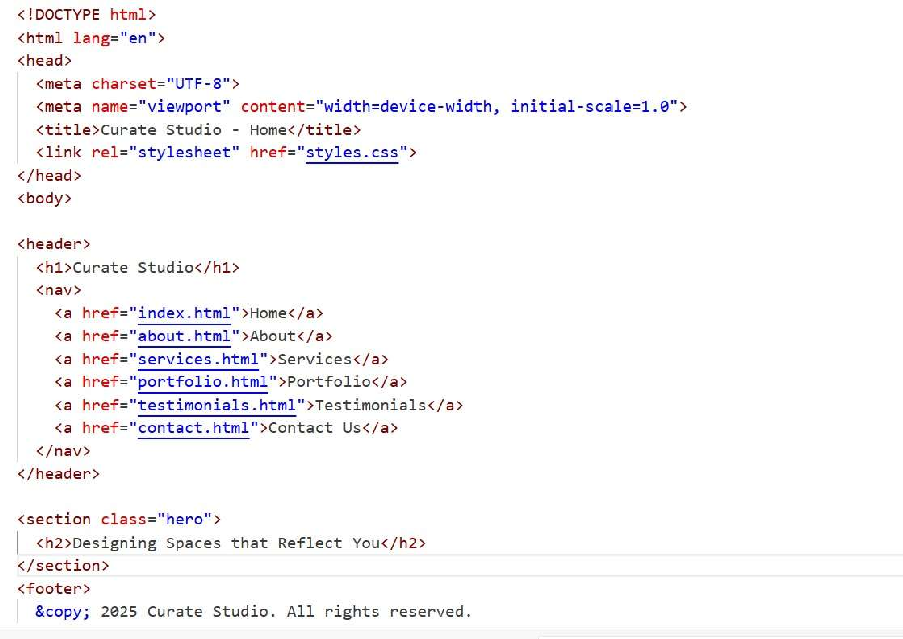

Index code:

# 13. Screenshots of Final Output

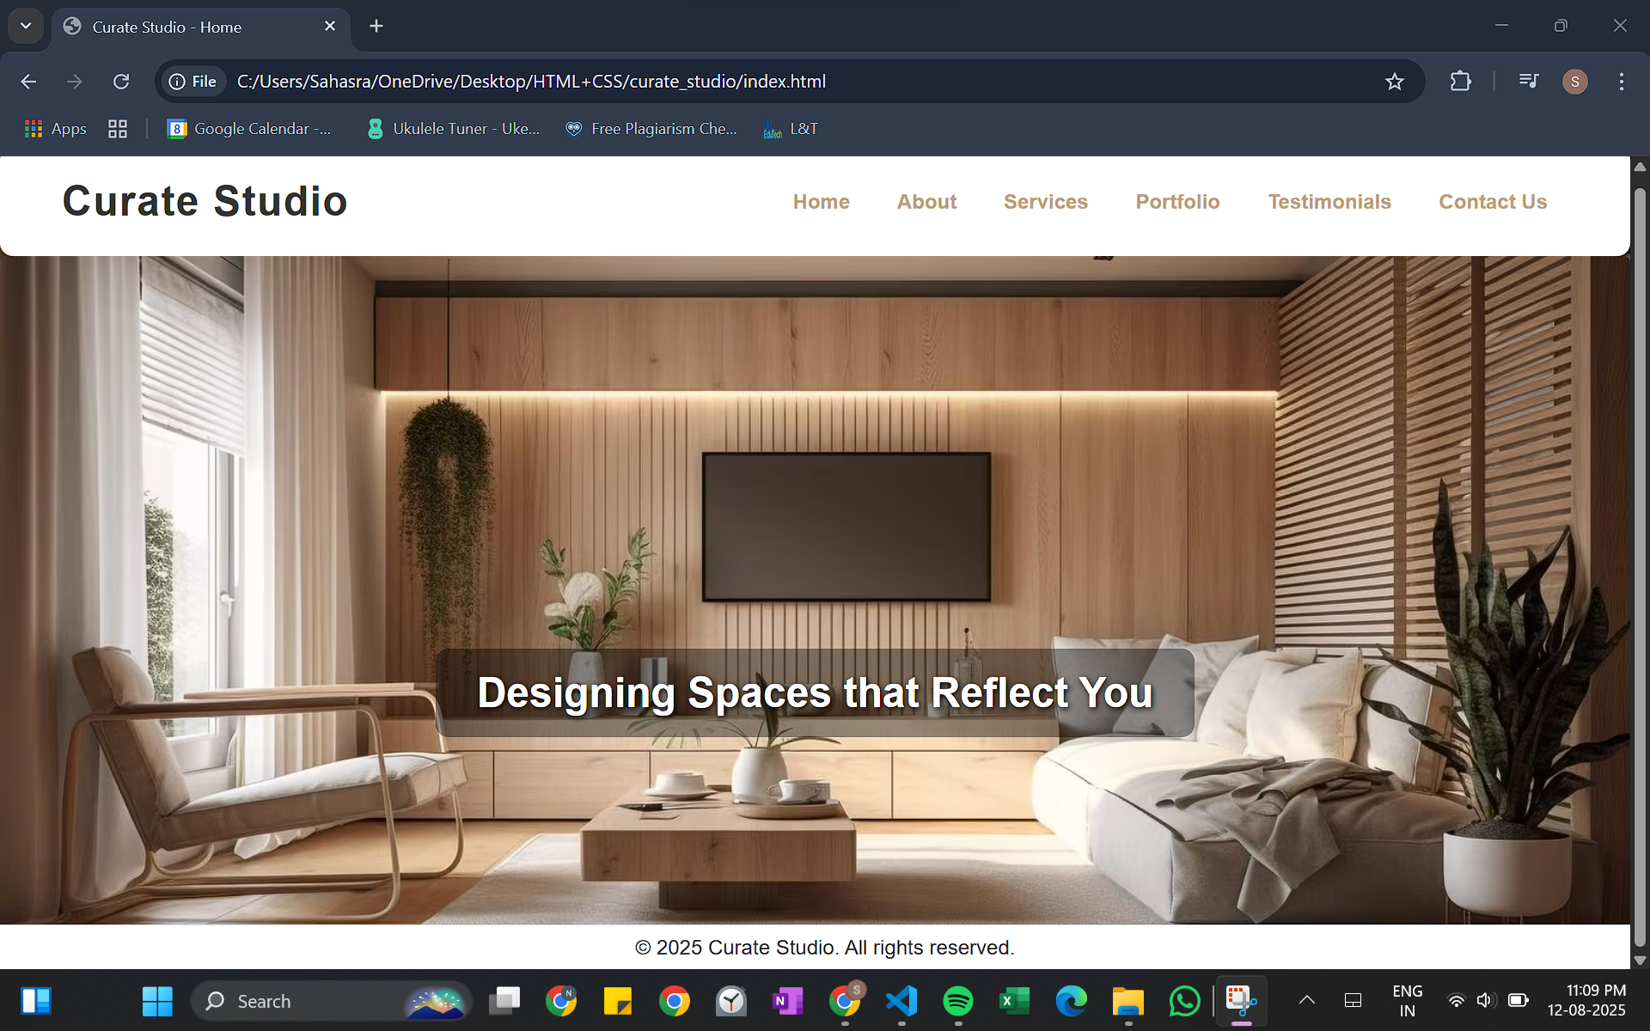

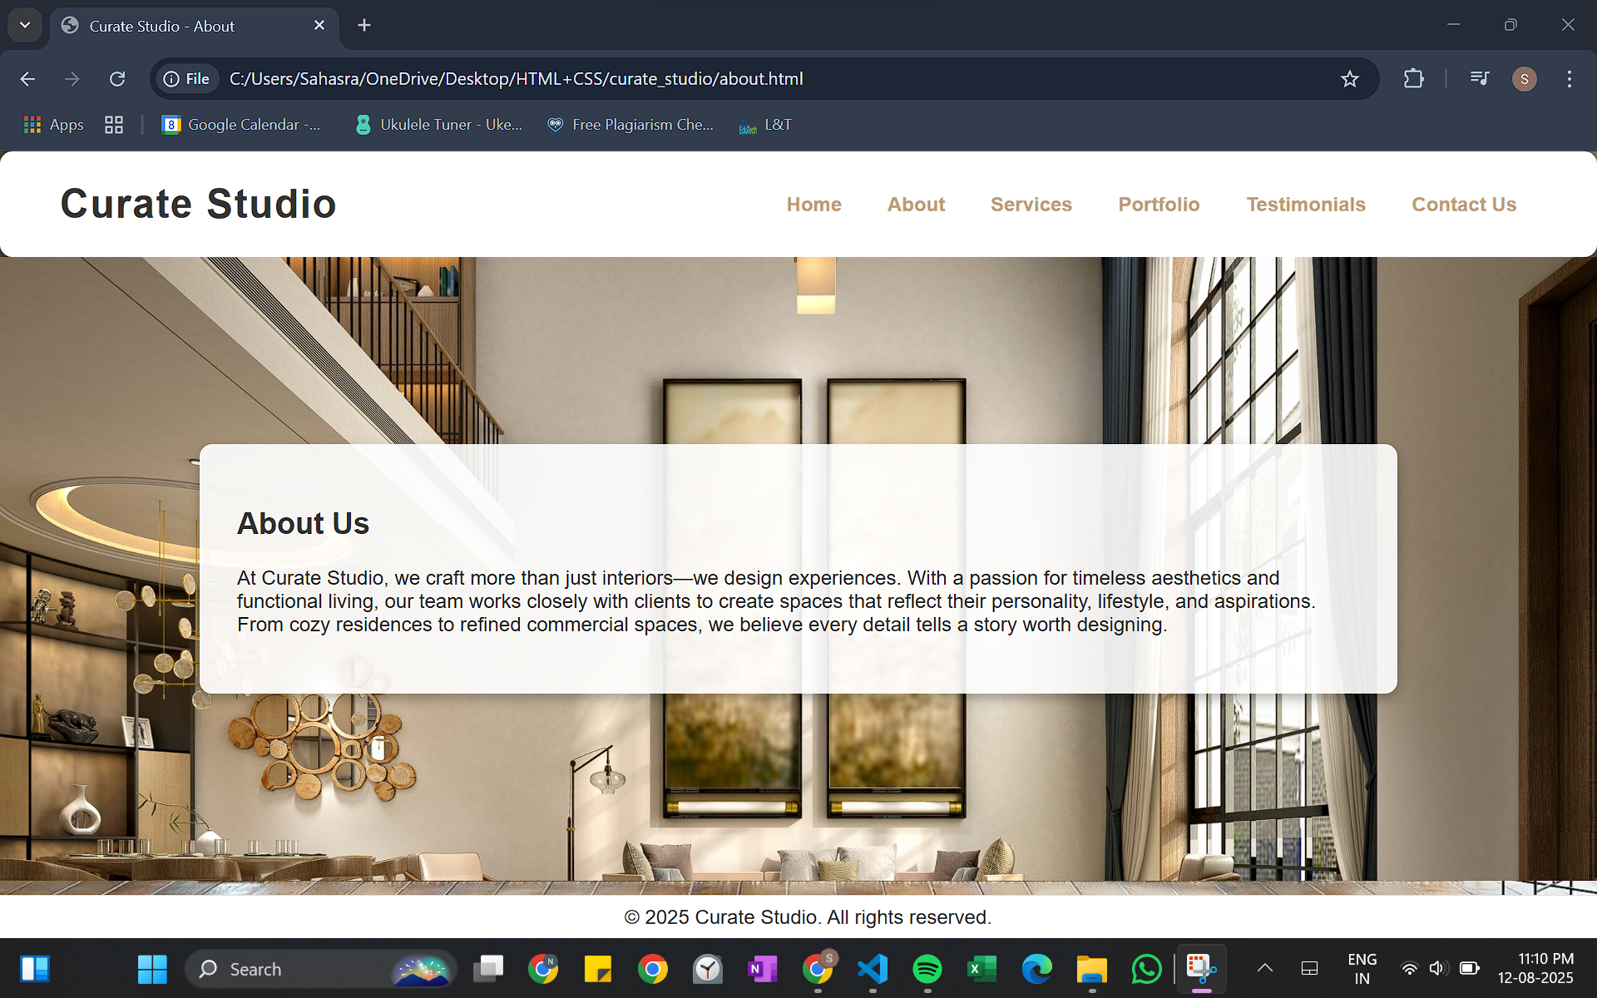

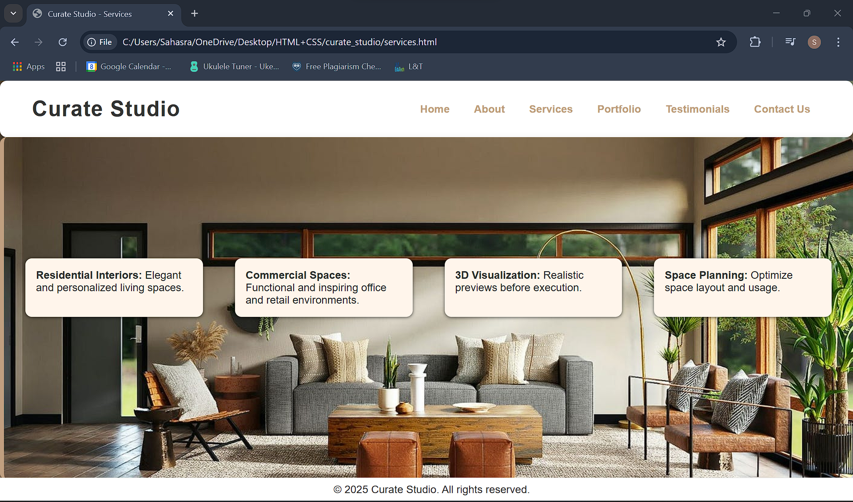

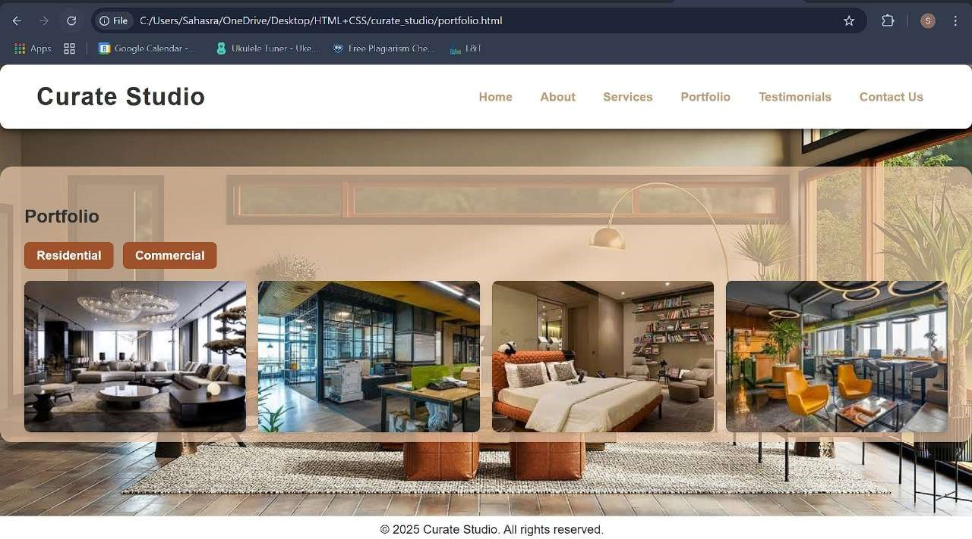

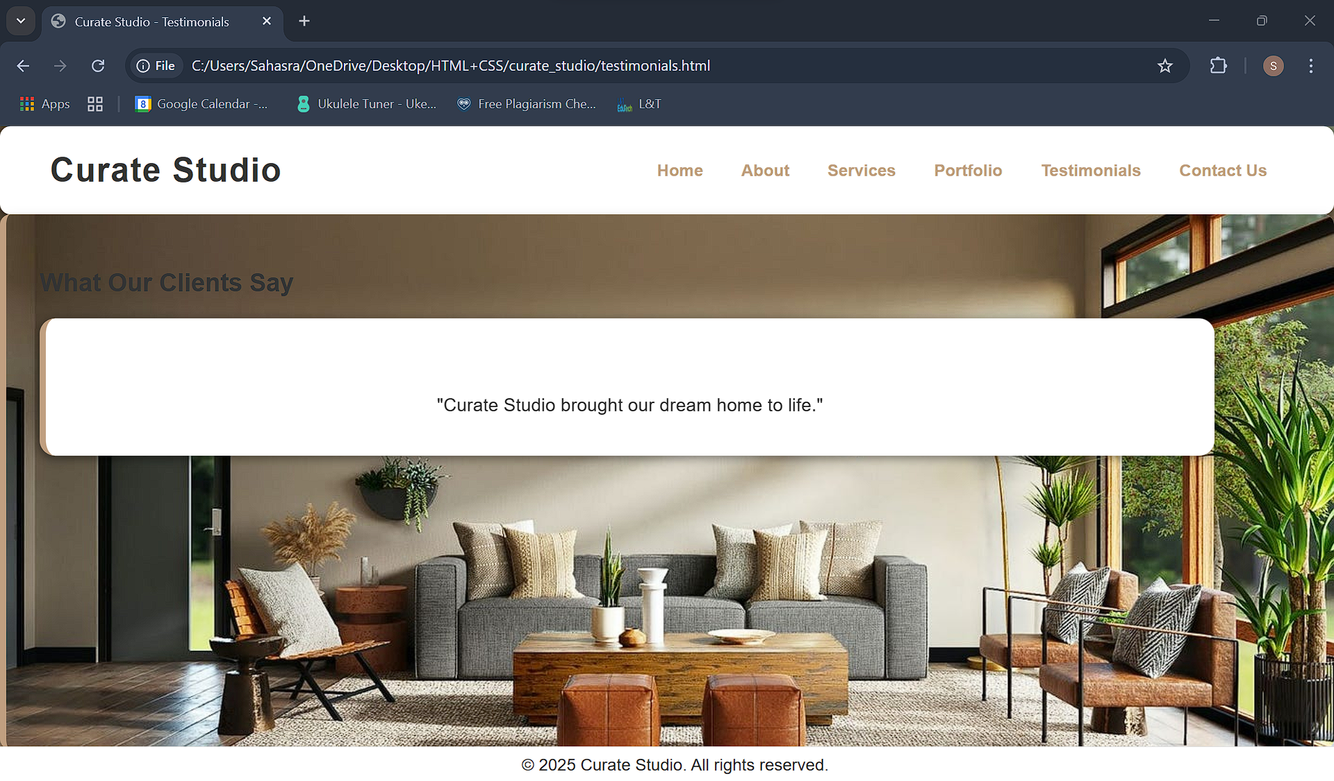

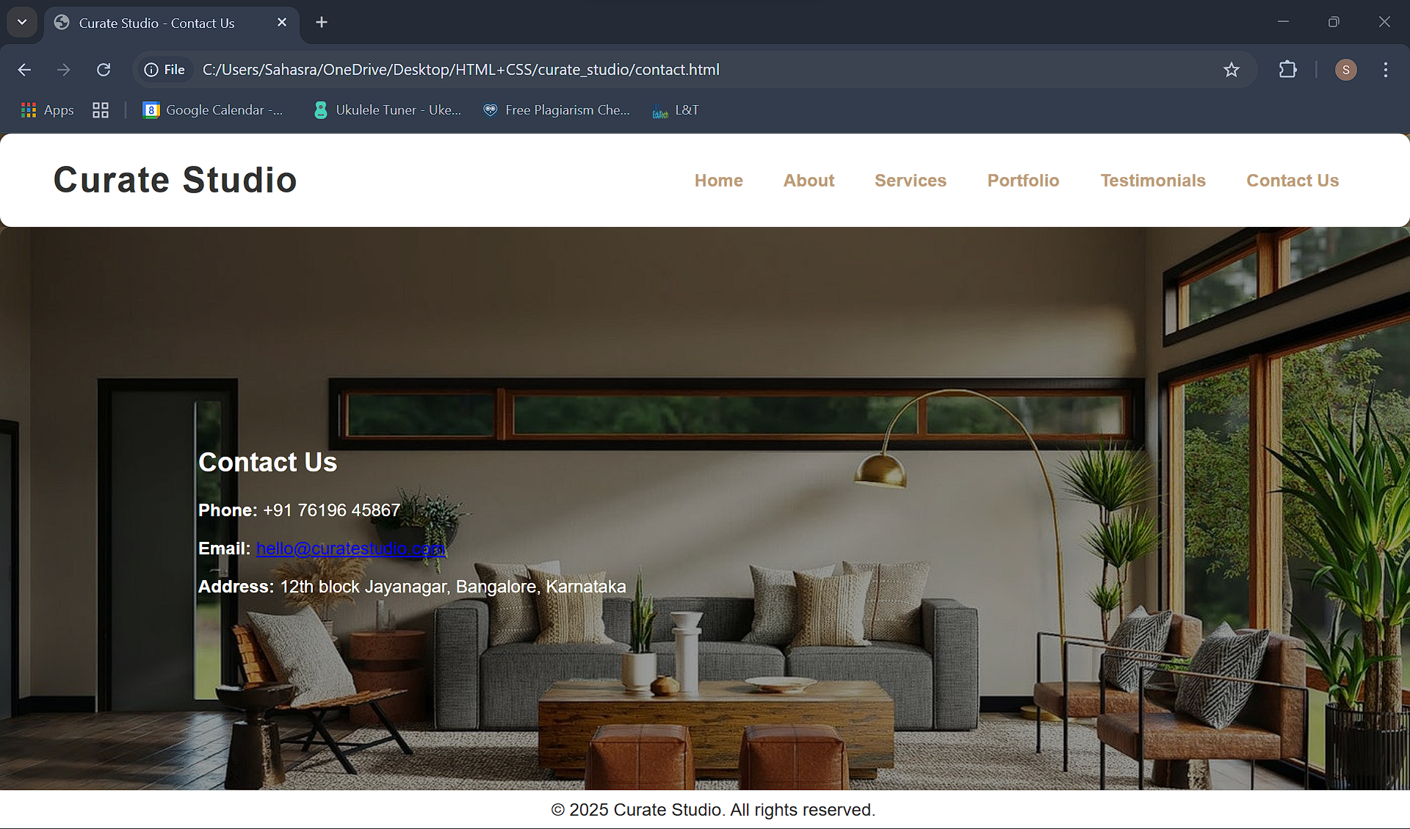

# **11. Conclusion**

This project strengthened my skills in building aesthetically-driven, responsive layouts using HTML and CSS. I learned advanced CSS techniques such as CSS-only filtering and animations, while also focusing on brand consistency and user-friendly navigation. It enhanced my understanding of structuring content effectively using semantic HTML tags, designing layouts with Flexbox and Grid, and maintaining design harmony through consistent color palettes, typography, and spacing.

Additionally, the process of creating a CSS-only filtering system pushed me to explore creative solutions without relying on JavaScript, improving my problem-solving and logical thinking abilities. Implementing the testimonials carousel helped me gain more confidence in using keyframe animations and transitions to create smoother, more engaging user experiences.

# **12. References**

* L&T LMS : https://learn.lntedutech.com/Landing/MyCourse